**INDIA GENERAL ELECTION RESULTS – 2024**

**PROBLEM STATEMENT**

# DASHBOARD 1: OVERVIEW ANALYSIS

The **India General Election Results – 2024** dashboard aims to provide a **comprehensive overview** of the election outcomes with a focus on **seat distribution among key alliances and independent candidates**. The dashboard will help **political analysts, researchers, and the general public** gain insights into the election performance of major political groups.

## KPI’s

1. **NDA Performance**

* Total **seats won by the NDA alliance**.

🡪insert a rounded rectangle h=265, w=405 , rounded corners=3, fill color= white, border=off, shadow=on with black

* To find the total seats won by NDA alliance we have to first segregate the parties in which alliance they fall, so we will write a CC to distribute them . (**refer to Party Alliance DAX** ) for the query .
* Now we have to find the total seats won by NDA & INDIA alliances throughout country, we write a new mesure in ‘partywise_results’ table



* Now add the image of modi , h=270, w=185 & keep it on the rectangular box. Also add the lotus symbol for NDA to the top left corner of the box. Create a card & add ‘Total seats’ measure to the card, & take ‘party alliance’ from partywise_results & add to the visual i.e card as a filter & select ‘NDA’ in the filter section. see the image below .

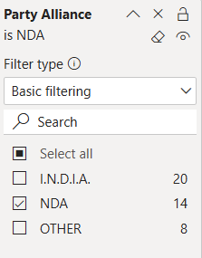

* Make necessary changes to the card & keep color of values as = EE6E14. Add a text box to add text ‘NDA Alliance’ ( calibri-12-Bold ) & place it below the lotus symbol
* **Percentage of total seats** secured by NDA.
* To fid the % of total seats by NDA , we have to find hoe many seats has NDA secured first , we create a new measure for that



* Now after finding ‘NDA Seats’ we find % of NDA seats by creating new measure & add this measure to a card & place it below ‘Total Seats’ card, make it to 0 decimal points.



* **Bookmark**: A grid matrix **details table** showing all **seats won by the NDA Alliance**.
* **Copy the visual on ‘details grid’ & paste it into dashboard 1 & remove ‘runner up candidate’ from columns & change bg color of visual & we need to add i button beside MODI symbol so that when we click that symbol it shows full data of NDA persons who won .**
* **Before adding button we need to filter only persons who won of NDA alliance , fo that go to filter 🡪 select NDA . Now add ‘I’ button beside modi & also an eye button on the top so that it will perform the action of ‘showing overview analysis’ dashboard by clicking on it .**
* **View 🡪bookmark & selection🡪 click on the visual & hide it 🡪 now add a bookmark for eye , name it as ‘show overview analysis’ 🡪 unhide visual & create another bookmark & name it as ‘show NDA Data’**
* **Do the same type of i button for INDIA & others also**

1. **I.N.D.I.A. Performance** :

🡪**we use the same type of measures that were used for finding NDA seats, % of NDA seats**

* Total **seats won by the I.N.D.I.A. alliance**.



* Change the color of text to = 0D6ABF,
* **Percentage of total seats** secured by I.N.D.I.A.



* **Bookmark**: A grid matrix **details table** showing all **seats won by the I.N.D.I.A.**

**Alliance**.

1. **Independent & Other Parties Performance**

* Total **seats won by independent candidates** and smaller parties.



* **Percentage of total seats** won by this group.



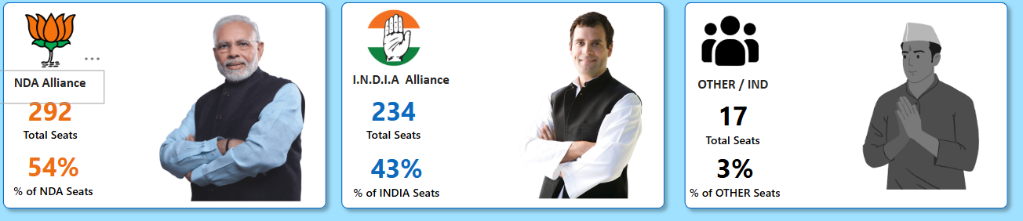

* **Bookmark**: A grid matrix **details table** showing all **seats won by Independent and Other Parties**.

**NDA Alliance Analysis**

* Add 2 rectangular boxes parallelly of h=143, after adding 2 boxes ,a dd another 2 boxes of same hight but w=140, to the left side of created boxes give the color of 1 box as =e66c37, & other box = same color as INDIA alliance
* **Identify all parties within NDA** that won seats.
* **Take a card & add ‘party’ column to the card & add ‘party alliance’ in the filter section & select NDA to get the count of parties**
* **Now add a card and in this card we must show all parties within NDA ,so we must display the party names as shortcuts. So we first extract the shortcut names of the parties by gng to partywise_results 🡪 make duplicate column of ‘party’ 🡪 use ‘split column’ from the duplicated column to extract the shortcut name 🡪 delete the duplicated column.**
* Now take a card & add ‘won’ to ‘data’ section with aggregation as sum , categories/small multiples =party short, add ‘party alliance’ to filter section to filter by NDA, & make necessary changes:

1. Cards = border & bg OFF
2. H= 65, w=1155, bg & header icons= OFF in general
3. Small multiple layout 🡪 single row 🡪 max =20 , border & gridlines =OFF
4. Title = 10 semibold
5. Values= semibold & 14, labels=off

* Now we need to add images on the top of each party name

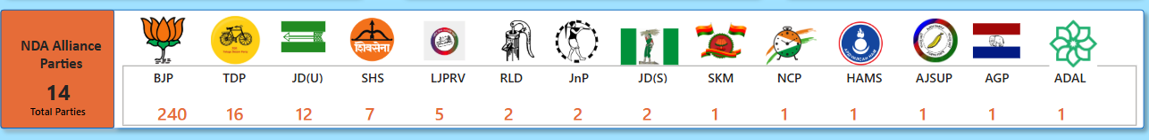

* Display **each party's seat count along with their party logos**.

## I.N.D.I.A. Alliance Analysis

**🡪 Now we need to follow the same steps for finding the INDIA alliance parties seats**

* **Identify all parties within I.N.D.I.A.** that won seats.
* Display **each party's seat count along with their party logos**.

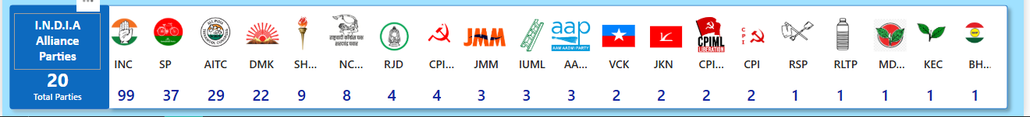

* After completion of INDIA alliance analysis, add INDIA map & lok sabha image to the top right corners & also add a card to display total no of seats & place it inside ‘lok sabha ‘ inserted image.
* **FINAL LOOK OF DASHBOARD 1:**

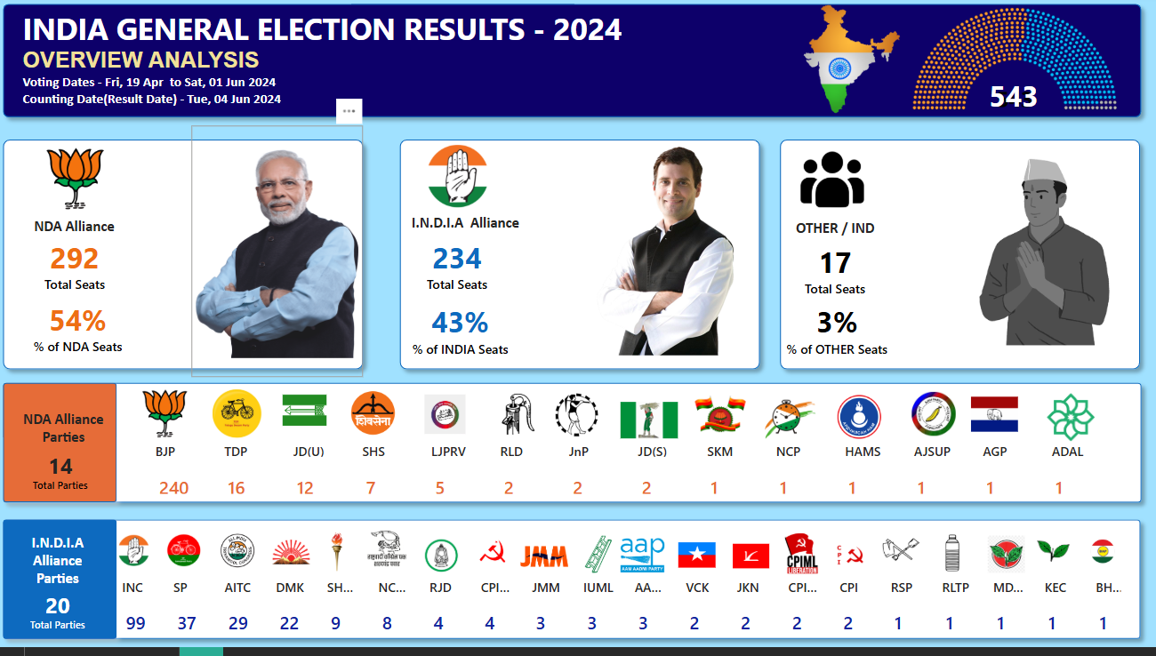

**STEPS TO BE FOLLOWED BEFORE DOING DASHBOARD 1 :**

1. **After loading the tables into the model check for column quality, distribution, column profile to check whether the data has any errors or not**
2. **ER DIAGRAM**

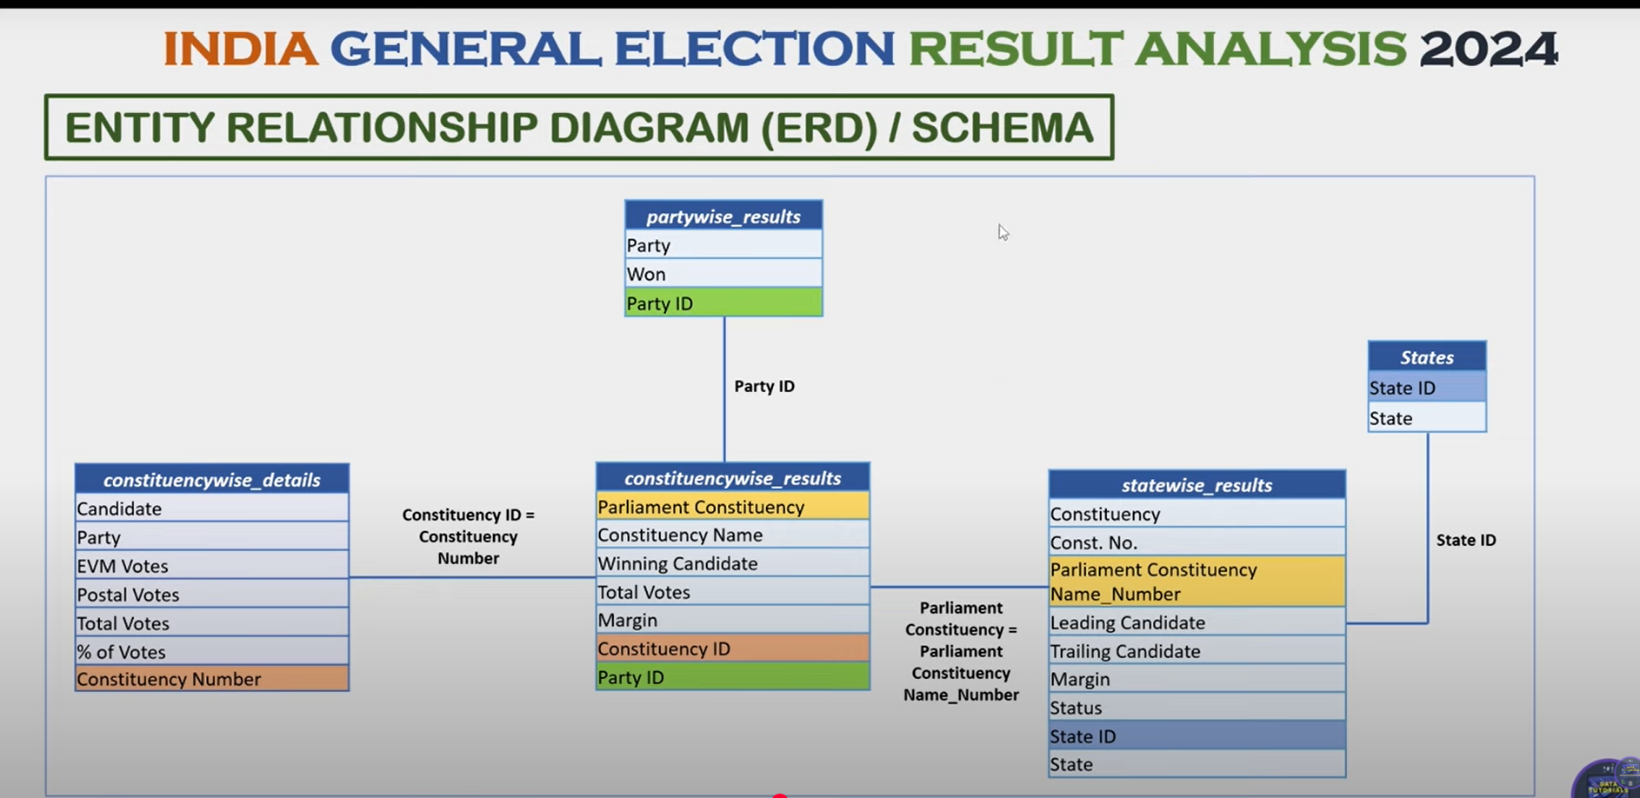

1. **Constituency id from ‘constituencywise_reuslts’ acts as PK , while constituency_number from ‘constituencywise_details ‘ acts as FK .**

**🡪party id from patrywise_resulst will be acting as PK, & FK will be partyid from constituencywise_results**



**CANVAS SETTINGS**

1. **H=700, w=1250, vertical alignment=middle, bg=A0E1FF, transparency=75**
2. **Add a rounded rectangle box h=140,w=1230, rounded corners=5%, color= #07036A , shadow=ON with 70%**
3. **Add a text box with title “INDIA GENERAL ELECTION RESULTS- 2024”, bg=OFF, font=24, white**

* **ADD another title into same text box as “OVERVIEW ANALYSIS” , font =arial, color= F0E199, SIZE=18**
* **Add voting dates * ‘counting dates’ below the ‘OVERVIEW ANALYSIS “ in the same text box, font=calibri, size=11**

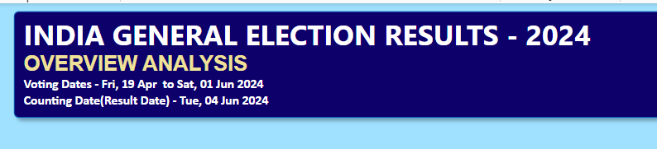

# DASHBOARD 2: STATE DEMOGRAPHIC ANALYSIS

The India General Election Results – 2024 dashboard provides an in-depth state-wise and constituency-wise analysis of the election outcomes. It offers a geographical breakdown of seat distributions, winning parties, and candidates, helping analysts, policymakers, and citizens understand the political landscape at different levels.

🡪 **make a duplicate copy of 1st dashboard & delete all the data ,cards & images. Keep only the heading & 1 rectangular shape**. **Change h =550, w=410 for the shape & add 2 similar shapes horizontally**

## 1. Total Seats, Alliance with Majority Seats, NDA Seats and I.N.D.I.A. Seats by State

* Displays **Total Seats, Alliance with Majority Seats, NDA Seats, and I.N.D.I.A. Seats** at the state level.
* **Visual Representation:**
  + **Map Chart by State**
  + Tooltip includes **Total Seats, Majority Alliance, NDA Seats, and I.N.D.I.A.**

**Seats** per state.

* + **Drill-through** to a **grid details table** showing all **underlying data per state**.

1. **take a filled map & add ‘state’ to legend & also to locations tabs, legends=OFF, map settings=grayscale, title=OFF, HEADER ICONS=off, h=410, w=365, tooltips=ON.**
2. **We need to find ‘NDA Seats’ using new measure in ‘constituencywise_results’ but we already created a measure for finding NDA Seats but why to create a new measure again because that measure was created in ‘partywise_results’ table , when we add this to the filled map, we get 272 for all states because there is a many-1 relationship between ‘constituencywise_results’ & partywise_results’ , due to this we are getting wrong count , after creating measure add this to tooltip**

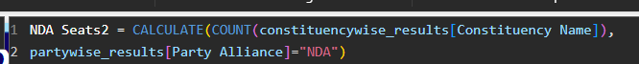

1. **Do the same for ‘INDIA Seats’**



1. **Create another measure for ‘Other’**

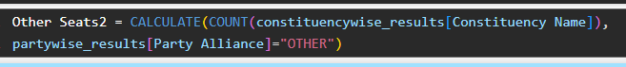

1. **Now we have to find ‘alliance with majority seats’ , create a new measure to find which alliance party has won in each state. Add this also to the tooltip**

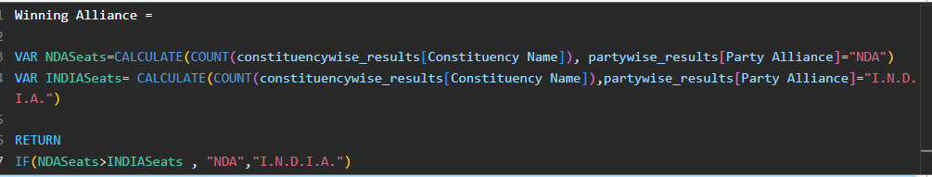

1. **Make changes to the tool tip , background=black, label=blue, values=white**
2. **Add some text t the text box present above the filled map**

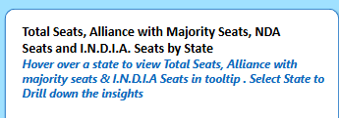

## 2. Winning Candidate & Party by Constituency

* Displays **Winning Candidate, Winning Party, Total Votes, and Total Margin** per constituency.
* **Visual Representation:**
  + **Bubble Map Chart**
  + Each Bubbles represent a **constituency.**
  + **Color-coded bubbles** to distinguish **NDA, I.N.D.I.A., and OTHER seats**.
  + **Drill-through** to a **grid details table** showing all **underlying constituency data**.

**1)add a map & add ‘state’ to location & ‘constituency’ to location from ‘statewise_results’ to location , after adding click on drill through functionality to see all constituencies info. Map settings= grayscale, title=OFF,**

**2) now we need to add ‘winning candidate’ as a tooltip , so winning candidate info is present in ‘constituencywise_results’ drag it to tooltip.**

**3) now we need to add which party & party alliance the winning candidate belongs , but those info is present in ‘partwise_results’ but this table is not connected directly to ‘state’ or ‘statewise results’ , so we need to write a calculation , create a new columns in ‘constituencywise_results’**



1. **we also want the alliance & add to tooltip**



1. **bring ‘total votes’ & ‘margin’ from ‘constituencywise_results’ to tooltips.**
2. **add ‘party alliance (results)’ from ‘constituencywise_results’ to ‘legend’ to display diff colors to diff winning party bubbles**

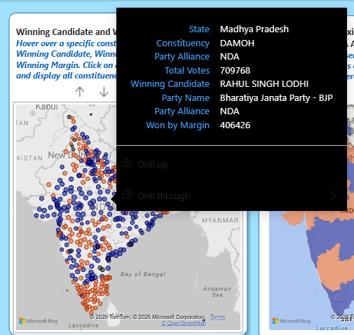

**3. State with the Maximum Seats won by either the NDA Alliance or the**

**I.N.D.I.A. Alliance**

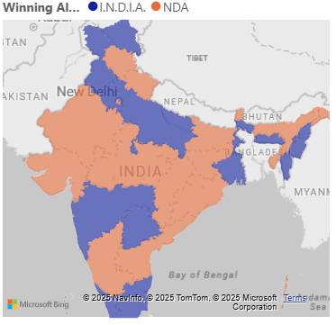

* Identifies the state where either **NDA or I.N.D.I.A. won the most seats**.
* **Visual Representation:**
  + **State-wise Map Chart**
  + **Color-coded states** based on the **majority alliance** in each state.
  + **Drill-through** to a **grid details table** showing all **underlying seat data** for that state.

1. Take a filled map & add ‘state’ to location, we should create a new column in ‘state’ table, add this below created column to legend. Change the colors for NDA & INDIA to blue & orange.

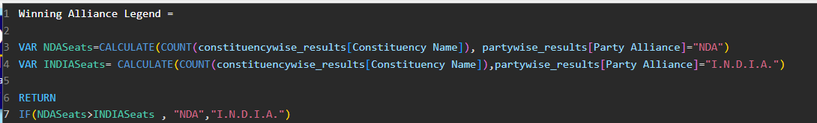

# DASHBOARD 3: POLITICAL LANDSCAPE BY STATE

The State Analysis dashboard provides a state-wise breakdown of the India General Election 2024 results. It enables users to analyze the performance of different political alliances and parties within a selected state, helping with comparative analysis, decision-making, and trend identification.

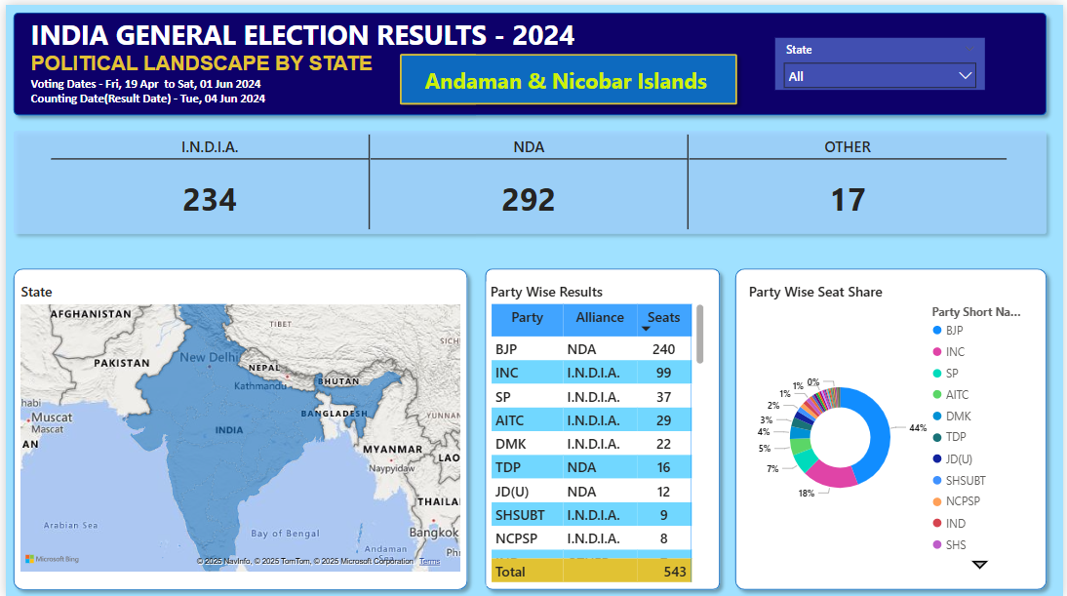

* 🡪 **Make a duplicate of the 2nd dashboard & change the title to ‘POLITICAL LANDSCAPE BY STATE’ & delete all charts & text boxes, keep only 1 rectangle shape & extend it to the end h=140, color= #a0d1ff, transparency=35%**
* **Add a new card with below formating & place it in the rectangle box**

**data= constituency name from ‘constituencywise_results’ with aggregation =count**

**categories= party alliance (results) from ‘constituencywise_results’**

**small multiples layout =single row**

**border=off**

**gridlines =on ,2 px, greyish**

**small multiple header = 13 with semibold, bg=OFF**

**call out values = bold , 28, center**

**lable=OFF**

**size & style = bg=OFF**

**cards = bg & border OFF**

**🡪 remove India map symbol & seats logo from the top & add a slicer & add ‘state’ with style as dropdown**

**Slicer header=10 semibold**

**General🡪 bg =414fb1**

**Values=11 & semibold**

## KPI’s

**Dynamic Selection:** Users can select a specific state from a filter.

• **Key Metrics Display:**

o Seats won by **I.N.D.I.A. Alliance**

o Seats won by **NDA Alliance**

o Seats won by **Independent & Other Parties Charts & Visualizations**

1. **State Map Chart:**

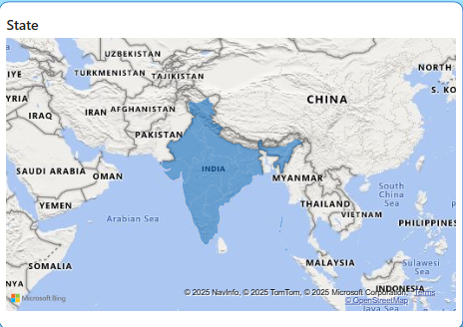

* + Displays the selected state with its constituency boundaries.
  + Highlights the distribution of seats across constituencies.
* **Take the place holder from prev dashboards & paste in this dashboard h=405, w=555**
* **Take a filled map**

**Location = state**

**Title🡪 12 semibold**

1. **Party-wise Result (Grid View):** 
   * Displays all parties that won seats in the selected state.
   * Includes the alliance affiliation of each party (NDA, I.N.D.I.A., or Independent).

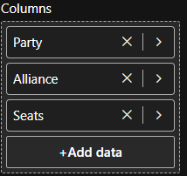 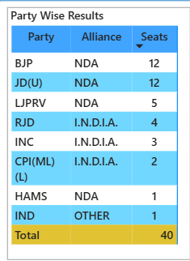

* **Add the same rectangle box with w=310, take a table grid**

**Rows= when we add ‘party short‘ from ‘partywise_results’ the remaining charts don’t change because its not connected in any manner to ‘state’ table. So we need to bring ‘party short’ to ‘constituencywise_results’ table . So we add a new column here**



* **Now add this to the table & filter by the state, we will see only those parties which participated in elections from that state.**
* **To add total seats won by that party in that state bring ‘constituency name’ to ‘values’ with aggregation as count , & also add ‘partyalliance(results)’ to the columns**

1. **Party-wise Seat Share (Donut Chart):** 
   * Represents the percentage share of total seats won by each party in the selected state.
   * Provides a visual comparison of party dominance within the state.

* **Take a donut chart & add**

**Legend= Party short name**

**Values= constituency name**

**Legend=ON**

**Title = Party wise seat share** 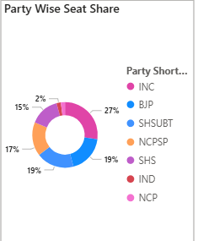

* Take a card & add ‘state’ to it , bg=off, 26, bold, & add it as placeholder beside the main heading

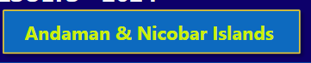

# DASHBOARD 4: CONSTITUENCY ANALYSIS

The **Constituency Analysis** dashboard provides an **in-depth analysis** of election results for a **selected constituency**, allowing users to examine **voter turnout, candidate performance, and seat outcomes**. This dashboard helps **political analysts, researchers, and citizens** gain insights into the **competitive landscape** at the constituency level.

* **Take duplicate of 3rd DASHBOARD & add ‘constituency name’ in slicer & also in the card to display the constituency name.**
* Now we need to add KPI’s , for rectangle box 1 set h=135, w= 290, & similarly add 3 boxes for 4 KPI’s
* **For 1st shape , color = e1c233**
* **For 2nd shape color = a0a7d8**
* **For 3rd shape , color = f3d4dc**
* **For 4th shape, color = a0d1ff**

## KPI’s - Primary (Overall Election Metrics for the Selected Constituency)

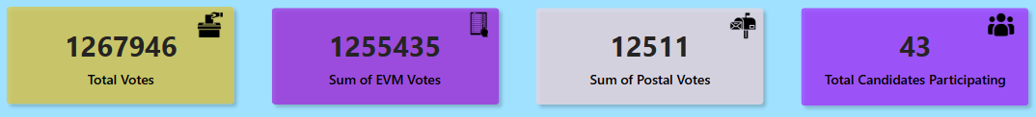

* **Total Votes** cast in the constituency.
* **take a card & add ‘total votes’ from ‘constituencywise_details’ table ,**

**value= 25 & semibold , bg = OFF,**

* **Total EVM Votes** recorded.
* **Total Postal Votes** counted.
* **Total Candidates** participating in the elections for that constituency.

## KPI’s - Secondary (Candidate Performance Overview)

1. **Winning Candidate:**

* **State**
* **Winning Candidate Name**
* **Party Name**

o **Total Votes Secured**

* **Vote Share (%)**

**🡪 insert the image & set h=425, w= 400**

**🡪 take card to add winning constituency , add ‘parliament constituency’ from ‘constituencywise_results’ . bg =OFF. Values🡪 size=20 & bold.**

**🡪 we must add the state name to display below constituency name, but there is no direct connection between i.e state & constituencywise_details, so we create a measure inside constituencywise_details**



**🡪add this emasure & keep this under the 1st created card**

* **Now take a text box and add as ‘WON’ with 24, GREEN color , bg=OFF, keep it under State name.**
* **Copy the state name card & add ‘winning candidate’ from constituency wise results size =15, color= AD5129**
* **Copy the above card & add ‘party name’ from “constituency wise results” , color= 893395**
* **Copy above card & add this below created measure in ‘constituencywise_details’ with size =12, color= #ad5129**

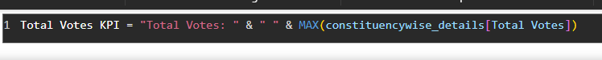

**🡪 add a new measure to find vote share % add add it to the card & keep it below the ‘Total votes KPI’ , color = 9071cd**

2. **Runner-up Candidate:**

* **State**
* **Candidate Name**

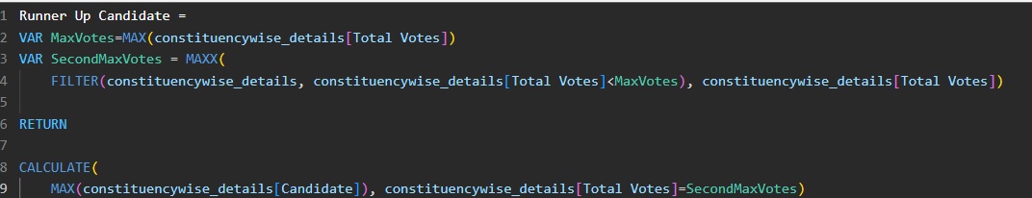

* **Party Name**

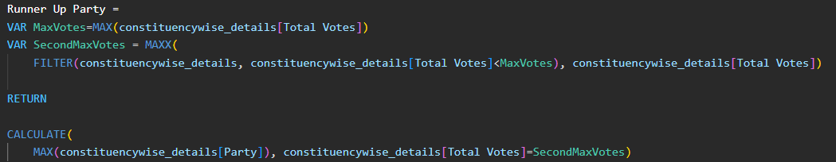

* **Total Votes Secured**

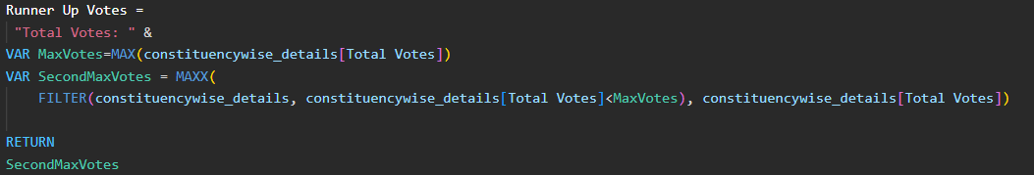

* **Vote Share (%)**

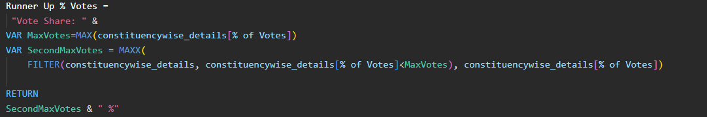

3. **2nd Runner-up Candidate:** o **State**

o **Candidate Name**

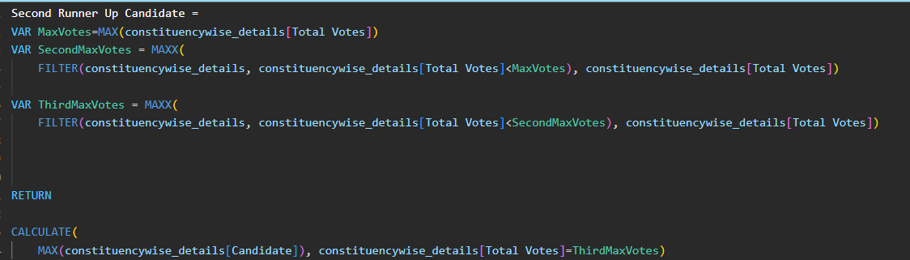

* **Party Name**

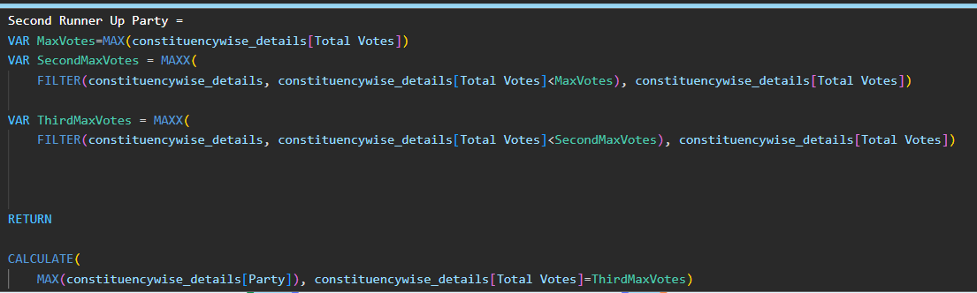

* **Total Votes Secured**

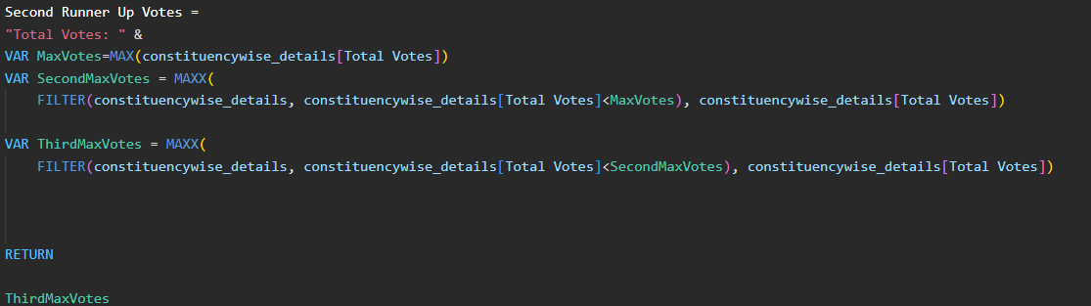

* **Vote Share (%)**

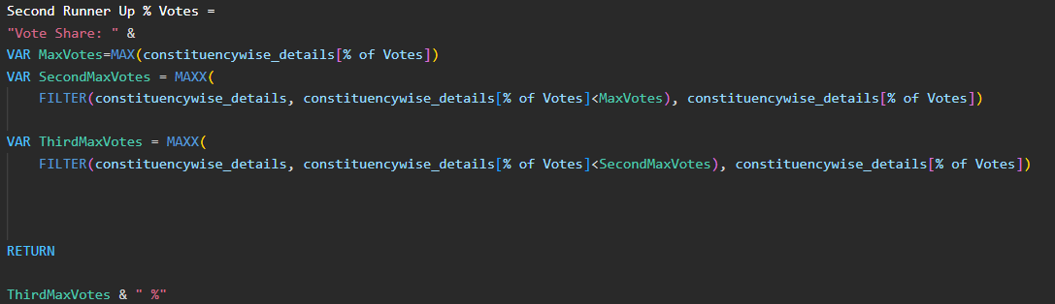

# DASHBOARD 5: DETAILS GRID

The **Details Grid** dashboard provides a **comprehensive tabular view** of the election results at the **constituency level**. It serves as a **data exploration tool**, allowing users to drill through from other dashboards and **export election data for further analysis**. **Grid View Fields**

**🡪take a duplicate of the 4th dashboard & remove all boxes & charts & insert rectangle shape with 1 % rounded corners .**

* **Take a table & add below fields**

The grid will display the following fields:

* **Constituency Name** from constituency wise results
* **Winning Candidate** from constituency wise results
* **Runner-Up Candidate** from constituency wise details
* **Party Name** (Winning Party) from constituency wise results
* **Party Alliance** (NDA, I.N.D.I.A., or Independent) from constituency wise results
* **EVM Votes** (Electronic Voting Machine Votes) from constituency wise details
* **Postal Votes** (Postal Ballots Counted) from constituency wise details
* **Total Votes** (Sum of EVM + Postal Votes) from constituency wise details
* **Margin** (Vote difference between Winner & Runner-Up) from constituency wise results
* **🡪values = 10 & calibri ,**
* **🡪 column headers =calibri & bold 10**
* **🡪 totals =OFF,**
* **For ‘total votes’ & ‘margin’ columns we add conditional formatting 🡪 data bars🡪 add ‘blue’ color for ‘total votes & yellow for ‘margin**
* **Next we need to add drill through features so that we can see underlined data . In ‘page information’ of details grid dashboard we will have drill through option add ‘won’ & ‘party short’ to the data & enable tooltips on the ‘NDA Alliance parties’ & ‘INDIA Alliance parties’ of dashboard1. When we hover over any party seats count we will be able to see the drill through option & a  will be created on ‘details grid’**
* 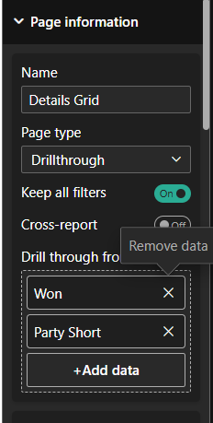
* Now we have to add drill through to **STATE DEMOGRAPHIC ANALYSIS,** for 1st chart add ‘total seats ‘ & ‘winning alliance’ under drill through data. Add ‘total votes ‘ & margin tot eh drill through section for 2nd chart
* Go to POLITICAL LANDSCAPE & add ‘state’ to drill through data & we can see drill through activated . Add ‘constituency name’ & ‘party alliance’ to enable DT for 2nd chart.
* Now we will add BOOKMARK , view🡪 select ‘bookmark’ & ‘selection’ 🡪 keep bookmark name as ‘show full data ‘. Now add a rectangle box & add text to it as ‘Show Full Data’ & under actions tab select bookmark as ‘Show full data ‘

## Functionalities

1. **Drill-Through Capability** o Users can **drill through from other dashboards** (State Analysis, Constituency Analysis, etc.) to view the detailed **underlying data** for a specific state or constituency.
2. **Data Export Option** o The grid should allow users to **export the data as an Excel file** for further external analysis.
3. **Show All Data Button (Using Bookmark)** o A **button will be provided** to refresh the grid and display **all relevant data** after filters are applied and drill-through actions are performed.

# DASHBOARD 6: LANDING PAGE

The **Landing Page** serves as the **central navigation hub** for the **India General Election Results 2024** dashboard. It allows users to seamlessly navigate between different analytical dashboards and ensures a **user-friendly experience** with easy access to all key insights.

🡪 take duplicate of ‘details grid ‘dashboard & delete all & add the image given as the background & rename the page as ‘LANDING PAGE ‘ & bring it to the front

## 1. Dashboard Navigation Menu

The landing page will provide **clickable buttons/cards** to navigate to the following dashboards:

* **Overview Analysis**
* **State Demographics**
* **Political Landscape by State**
* **Constituency Analysis**

Each button will be designed to provide **quick access** to the respective dashboard with a **clear label and relevant icon**.

## 2. Home Button on Each Dashboard

• Each dashboard will include a **Home Button** that allows users to quickly return to the **Landing Page** with a single click.

## 3. Interactive UI Elements

* **Minimalist & Clean Design** for easy readability.
* **Icons & Color Coding** for better visualization and quick recognition.
* **Hover Effects** to highlight active selections.

## 4. Responsive Layout

• The landing page will be optimized for **different screen sizes**, ensuring a smooth experience on desktops, tablets, and large screens.